Brunch is at the Pine Lake Ale House (640 228th Ave NE, Sammamish, WA 98074)

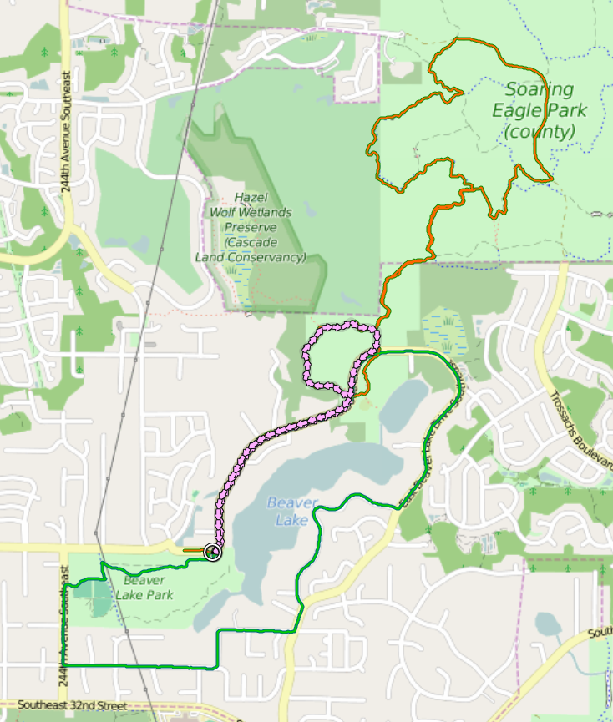

**Beaver Lake / Soaring Eagle run**

There are three set courses:

A (6 miles, mostly trail running, Orange): West Beaver Lake Drive -> Beaver Lake Preserve (clockwise) 🡪 Soaring Eagle

B (4.2 miles, almost all road, Green): Around Beaver Lake (clockwise) cutting back through Beaver Lake Park. Skip the park at the end and stay on the road if you have a stroller.

C (2.5 miles, mostly road, Pink): West Beaver Lake Drive 🡪 Beaver Lake Preserve (clockwise)

Turns are marked by arrows with a letter where needed to distinguish one run from another.

**Brunch:**

Pine Lake Ale House

[640 228th Ave NE, Sammamish, WA 98074](https://www.bing.com/local?lid=YN925x15787343&id=YN925x15787343&q=Pine+Lake+Ale+House&name=Pine+Lake+Ale+House&cp=47.6154899597168%7e-122.035102844238&ppois=47.6154899597168_-122.035102844238_Pine+Lake+Ale+House)

**Route A turn-by-turn:**

🡪 Left into Beaver Lake Preserve after about .75 miles (where there is the “no bikes” sign)

🡪 clockwise to T-intersection; route C goes right and route A left towards Soaring Eagle via Kipper Preserve

🡪 20

🡪 21

🡪26

🡪6

🡪5

🡪 jog up then right onto Pipeline Trail, then to 16

🡪23

🡪 22

🡪 21

🡪 20

🡪 back out, right onto West Beaver Lake

🡪 to brunch

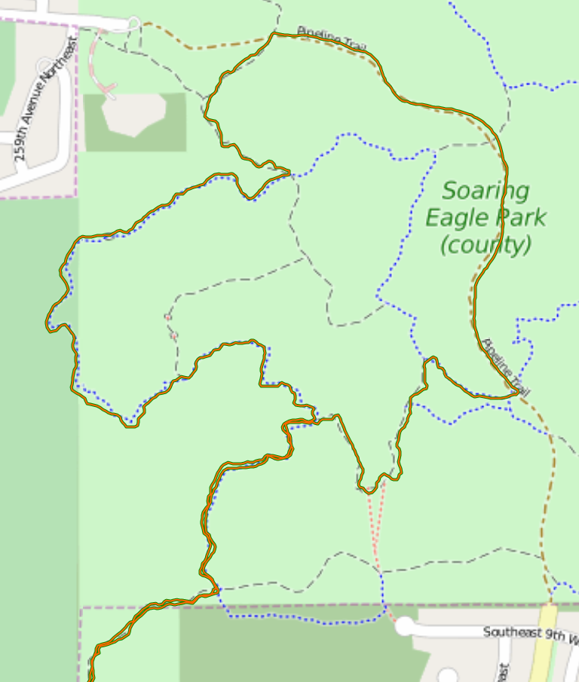

**23**

**22**

**16**

**5**

**6**

**26**

**21**

**20**