Brunch: At Art Marble 21 (731 Westlake Ave N). Drive back south on Westlake a few minutes to the split of Westlake and 9th Ave.) Park nearby and enjoy brunch!

Course Description: All three routes start north on the trail and up the Westlake sidewalk to the Fremont bridge, then across and immediately down the stairs to the trail below.

3 mile (5k) out and back: head along the water to Gas Works, up to the top of the hill, drop and do 10 pushups, and then back for brunch.
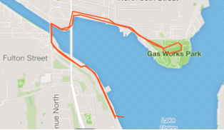

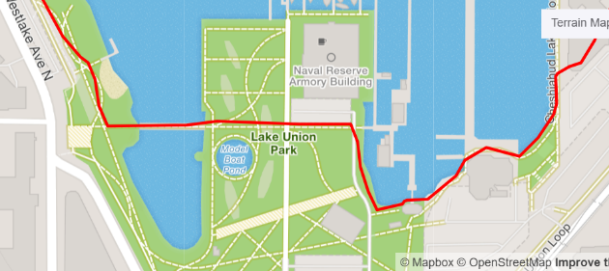
6 mile (10k) loop: it's the round-lake-Union run. Keep going on the trail past Gas Works, continue to the confusing intersection of NE 40th with itself (taking NE 40th up the hill to the University Bridge.) Cross the University Bridge and stay on Eastlake Ave until you reach Roanoke, and then right and back down to the water. Once you get to Yale Ave I'd suggest going in from the parking lots to run along the water, and then just stick to the water, past the Wooden Boat Center, across the bridge just north of the model boat pond, and then back north on the trail.
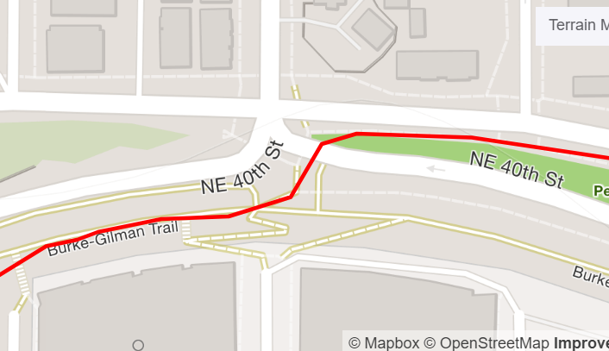
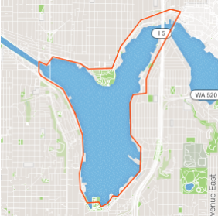

8 mile (12.5k) or so loop: it's a bit urban gritty, but you get to see the salmon swimming around the locks. Take the Burke Gilman west until you hit the Burke Gilman Missing Link (i.e,. gritty Ballard streets) and keep going along the north side of the canal until you reach the locks. Run through the hordes of tourists and find the shortest path across the locks at that point. Once you get to the other side, head south-east along the water on W Commodore Way and 21st Ave W until (at W Emerson) you see the Ship Canal trail. Follow that straight back to the start.
